**Fluid Dynamics and Cardiology Homework Problems**

**Swarthmore College Introductory Physics for the Life Sciences**

**Problem 1. Volume Flow Rate in the Heart**

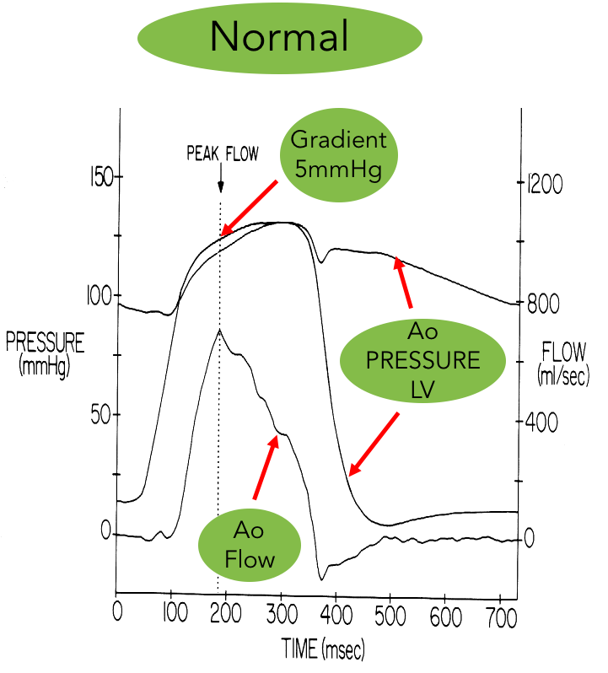

Estimate the average volume flow rate, in liters per minute, for the normal patient shown in the figure, using the data shown in the figure. The units of flow on the right axis are mL/s. Assume that the heart’s pumping cycle shown repeats every second.

**Problem 2. Blood Flow Dynamics**

The aorta (the main blood vessel taking oxygenated blood out of the heart) has a radius of about 1.3 cm. It then branches into several major arteries with total cross-sectional area of about 20 cm2.

1. Given that the flow velocity of blood in the aorta (as opposed to the aortic valve) is about 100 cm/s, what is the total volume flow rate of the blood passing through the aorta?

1. If all the blood that flows through the aorta then branches into the major arteries, what is the velocity of blood in the major arteries?
2. The blood flowing in the major arteries then branches into the capillaries. If the velocity of blood in the capillaries is measured[1] to be 0.07 cm/s, what is the total cross-sectional area of the capillaries?

**Problem 3. Diseased Arteries**

The radius of a normal coronary artery is 1.5 mm and its length varies among individuals but is typically about 4.0 cm. A diseased artery might have the radius of the open part of the artery reduced to 1.2 mm. Calculate the flow resistance (proportionality between *∆p* and volume flow rate) for both the normal and the diseased artery.

**Problem 4. Atherosclerosis**

Coronary arteries are responsible for supplying oxygenated blood to heart muscle. In the disease state called atherosclerosis, deposits of plaque accumulate on the arterial walls, narrowing the artery in places. A common physiological response to the reduced flow that would result from this narrowing is to increase the blood pressure in order to maintain a healthy flow rate. In a healthy adult, the blood pressure cycles as the heart beats between a maximum value, referred to as the systolic pressure, and a minimum, the diastolic pressure (as illustrated in the figure for Problem 1). Elevation of this pressure due to atherosclerosis or other disease factors to a maximum (systolic) pressure of roughly 140 mm Hg or more is associated with a number of health problems.

1. The radius of a normal coronary artery is 1.5 mm and its length varies among individuals but is typically about 4.0 cm. Explain why it makes sense to model the flow through the coronary arteries as viscous.
2. Consider a diseased artery in which the radius of the open part of the artery has been reduced to 1.2 mm. For the same change in pressure from one end of the artery to the other,, calculate the volume flow rate in a diseased coronary artery, *Q*diseased, as a multiple of the flow rate in a normal artery, *Q*normal.
3. The body attempts to compensate for the reduced open area by increasing the blood pressure. By what factor must the pressure drop across the artery (*Δp*) increase in the diseased artery to achieve a volume flow rate equal to that through the healthy artery?

**Problem 5. Measured Cardiac Flow Speeds**

To determine the severity of disease in a patient with a narrowed aortic valve, cardiologists use measurements of flow speed to determine the cross-sectional area of the aortic valve.

1. Measurements show that for one particular patient, the flow speed of the blood at the very top of the left ventricle, just before entering the aortic valve, is 1.0 m/s, and the flow velocity in the aortic valve is 3.8 m/s. The diameter of the entrance area at the top of the left ventricle is measured to be 2.5 cm. What is the open area of the aortic valve?
2. Suppose the measurement of the diameter of the entrance area has 10% error (i.e. could be between 90% and 110% of the measured value). What is the range of possible values of the open area of the aortic valve? Does this correspond to more or less than a 10% error in the valve area?
3. Several arteries extend off the curved part of the aorta. Consider three such arteries with diameters of 1 cm, 0.50 cm, and 0.75 cm respectively. For the purpose of this problem, assume that each is about 15 cm long and the same pressure difference exists across each of the arteries. In which of these three arteries will the **volume flow rate** be greatest? Explain briefly, including which flow model (viscous or nonviscous) you are using and why.

[Also assigned basic fluid dynamics problems from Knight, Physics for Scientists and Engineers, 4th edition: Chapter 15, Problems 59, 61, and 66.]

1. Value from Vogel, *Comparative Biomechanics*, 2nd edition, p. 187.